

## Industrial Training Report

Mrs.Vrushali Argade, [Industrial Supervisor]

Brand Technology— Janki Heights, Nr Bank of Maharashtra, Chaupati

Karanja, Chitle Road, Ahmednagar-414001

**DD:** +919975167791 **E:** [Info@Brandtechnology.In](mailto:info@brandtechnology.in%20%20)



# Maharashtra State Board of Technical Education Certificate of Completion

**Of Industrial Training**

This Is to Certify That Mr. Padale Avinash Ravindra With Enrollment No 1801300181Has Successfully Completed Industrial Training (22409) In Brand TechnologyFrom 22-06-2020 To 18-07-2020 For Partial Fulfillment Towards Completion of Diploma inComputer Engineering from Government Polytechnic, Ahmednagar. Institute Code 0130.

### Mentor Industrial Supervisor

[Mrs.S.B. Chavan] [Mrs.Vrushali Argade]

**Seal of**

**Institute**

### H.O.D Principal

[Mr. Sudhir Muley] [Mr. Mukund Satarakar]

Abstract

In the Given Report the Information About Industry, All the Environment and Experiences During the Four Weeks of Industrial Training at Brand Technology Had Been Mentioned in The Given Report. Webpage Designing and Programming Using PHP, HTML, CSS, Working & Testing on Live Project Such Things Experienced and Learned During Four Weeks of Industrial Training.

## Acknowledgement

We Are Thankful to Our Industrial Supervisor Mrs.Vrushali Argade And Mentor Mrs.S.B.Chavan For Completing Industrial Training Under Their Observations and Guidelines. We Are Pleased to Take the Opportunity to Do Industrial Training and Prepare Report On **“Industrial Training at Brand Technology”**

The Project Would Not Have Been Completed Without the Valuable Guidance and Encouragement of Industrial Supervisor and College Staff.

## Contents

#### Title Page

* Certificate
* Abstract
* Acknowledgement
* Contents
  + Chapter 1: Organizational Structure
  + Chapter 2: Introduction to Industry
  + Chapter 3: Types of Major Equipment/Systems/Instruments Used
  + Chapter 4: Software Development Process
  + Chapter 5: Testing of Live Projects
  + Chapter 6: Handling Live Projects
  + Chapter 7: Safety Procedures
  + Chapter 8: Particulars of Practical Experiences
  + Chapter 9: Short Report of Handled Project
  + Chapter 10: Special Challenging Experiences
* References

**Contents: -**

**Chapter 1: Organizational Structure of Brand Technology**

Brand Technology Is Small Scale Business Where the Software’s Are Developed for The Government Aided and Private Type of Businesses and Organizations.

**Company Name** – Brand Technology

**Company Location** – Janki Height,Nr Bank Of Maharastra,Chaupati Karanja,Chitle Road,Ahmednagar-

414001

**Company Domain** – PHP, Java Script, Python,HTML,SQL, Core Java,C#.Net Training,Asp.Net.

**Company Employees** – Around 10 To 15.

**Company Product – 1**. Construction

2.E-Learning

3. Class System

4. Money Hishob

**Chapter 2: Introduction Of Industry (Type Of Projects And Services, History, Turn Over And Number Of Employee Etc.)**

Brand Technology Is Website Design Company in Ahmednagar, Which Is Founded in FEB 2017 by Bade S.M with The Main Aim Is to Develop the Automotive Solutions for Business with To Improve Business Quality with Respect to End User Through Different IT Services.

We Also Provide Digital Activity for Business Enhancement Such as Social Media Marketing, Digital Promotion, SMS Services Like Transactional and Promotional Messages, WhatsApp Marketing, And Many Other Social Media Resources Which Helps to Boost Up Business Level on Online to Get Better Response Tare from Customer.

### Types of Products and Services:

* Software Development.
* Website Development.
* Apps Development.
* Digital Marketing.
* Web Designing Using PHP, JSP, ASP.Net, HTML5 And Java C#.

# Recent Projects

Brand Technology Prepared Reliable Projects as Such.

1. Apanaapp.In:

The Purpose of Designing This Application Is Government Works, Personal as Well As Official Works. This Is Also Website and Used for Contacting the Government Workers. By Using This Application, We Can Contact the Government Workers Such as Ambulance, Bank, Hospital, College as Well As We Can Contact Various Shops, Hotels, Travels and Contractors. This Application Is More Helpful for Us.

2. Apanamart.In:

The Objective of Apanaamart Application Is to Develop for A Shopping Purpose. The Application Gives The Information About Various Products. This Application Gives Details to Customer Like Product Name, Product Image, Quantity, Price Details Etc. This Application Also Shows the Offers on That Product Which Customer Choose.

# Chapter 3: Types of Major Systems/ Instruments Used in Industry with Their Specification, Approximant Cost and Specific Use

### DIR-615 WIRELESS N 300 ROUTERS

1. Device Interfaces: Wireless N 300 Four 10/100 LAN Ports

10/100 WAN (Internet) Port

1. Standards: IEEE 802.11n/G/B, IEEE 802.3, IEEE 802.3u, IEEE 802.3x
2. Antennas: 5dbi External Antenna
3. Wireless Security: WPA & WPA2 (Wi-Fi Protected Access)

Wi-Fi Protected Setup (WPS) – PIN

1. Advanced Features: Web Setup Wizard Pump Support Active Firewall – Network

Address Translation (NAT) Repeater Mode

Description

The DIR-615 Wireless N 300 Router Is an Attractive, High-Performance Router That Makes It Easy to Share Your Broadband Internet Connection with All Your Devices. The External Antennas Increase Your Wireless Network’s Coverage So You Can Avoid “Dead Spots” And Get A Reliable Connection in More Places Throughout Your Home. The DIR-615 Also Has Repeater Mode, Which Allows You to Extend the Range of Your Existing Wireless Network. It Approx. Costs for Rs.1000/-

Features

* Wireless N Technology
* Repeater Mode to Extend the Reach of Your Existing Wireless Network
* Host of Security Features to Keep the Network Safe
* Flexible Connectivity for Your Devices
* Web Browser-Based Setup and Configuration

# Chapter 4: Web Development Process Along with Project Planning and Development Methods

During Four Week of Industrial Training, Our Target Was to Complete Our Website and We Completed That. Firstly, We Prepared Our Resources Which Will Required for Our Project Such as Centralized Database Creation and Network Setup.

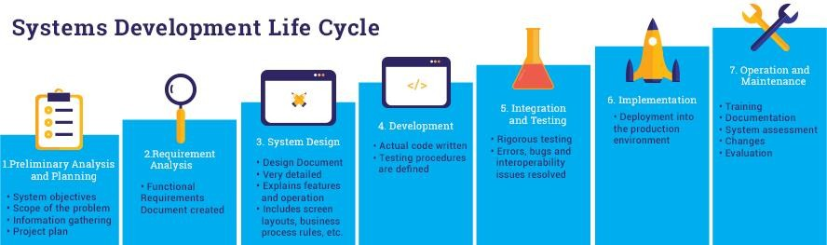

# Web Development Process

* 1. Information Gathering

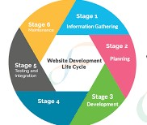

* 1. Planning
  2. Designing
  3. Content Writing and Assembly
  4. Coding
  5. Testing
  6. Maintenance

# Chapter 5: Testing of Our Projects

We Test the MARVEL STUDIO INFO Website During Four Week of Industrial Training. We Performed Testing on That Website and Generate Test Cases and Also After Testing the Modules of The Website. We Prepare the Tested Report for Summarization of Testing and Writing Some Suggestions.



### Test MARVEL STUDIO INFO: -

**Summarization**:

We Test the Website in Such A Way That We Tried to Insert Invalid Input Data. In This Testing, Website Fails Due to Insertion and Updating of Invalid Input Data. We Tested the Admin Login Form in Such Way That We Tried to Login Without Filling Valid Input. We Also Tested That the Data Given by Admin and The Feedback Given by Students Is Properly Storing in Database or Not. In This Testing Admin Failed To

Login Multiple Times.

# Chapter 6: Major System Handling (Servers and Clients) And System Handling Procedures.

* + **Computer Systems**

###### LENOVO (Server)

This System Used as A Server Purpose. Here the Centralized Database Was Saved and It Was Centralized System in The Network of Star Topology Which Resides in Company. It Was Handled with Care to Avoid Data Loss and Preventing Network Failure.

###### Features:

Processor 2.79 Ghz, 4GB RAM 500GB HDD, Run on Windows 7 OS, Operating System 32 Bits

###### ASUS (Client)

This System Used as The Client System in The Network. This Was Used for Making Documentation of The Project.

###### Features:

Processor 3.40 Ghz, 2GB RAM, 320GB HDD, Run on Windows 7 OS, Operating System 32 Bits

###### HP (Stand-Alone System)

This System Used as The Client System in The Network. This Was Used in Project Development of The Project for Coding, Testing, Designing. Backup of The Software Was Stored in This System in Case of Power Failure Which Causes the Above Systems Failed to Start.

###### Features:

Processor 2.40 Ghz, 8GB RAM, 1 TB HDD, Run on Windows 10 OS, Operating System 64 Bits

# Chapter 7: Safety Procedures Followed

As Worked in Software Industry but From Our Home Town There Was the Less Risk in Our Environment. Still We Follow Some Safety Procedure to Avoid System Damage and Avoid Data Loss.

1. Turn Off Systems Properly to Avoid System Failure.
2. Setting Up Network Connection After Stabling the System Performance to Avoid Network Failure.
3. Storing Software Backup and Documents Backup in Case of Failure.
4. Proper Handling of Sublime Text 3 To Avoid Data Inconsistency Problems Occurs from Data Concurrency.

# Chapter 8: Particulars of Practical Experiences in Industry (If Any in Development/Coding/Testing/Deployment)

### WEBPAGE DEVELOPER

Becoming A Webpage Developer, Also Known as A Computer Programmer, I Was Playing A Key Role in The Design, Testing and Maintenance of Webpages. The Website We Create Are Likely to Help Businesses Be More Efficient and Provide A Better Service.

Based on My Company’s Particular Requirements, I Will Be Responsible for Designing and Coding Individual Webpages or Providing an Entirely New Website Resource. The Specification I Was Work on Was Often Come from IT Analysts.

### As A Webpage Developer, Your List of Tasks Can Include:

* Reviewing Current Systems and Analyzing the Work of Those Webpages.
* Presenting Ideas for System Improvements, Including Project Proposals
* Producing Detailed Specifications and Writing the Program Codes
* Testing the Webpages in Controlled, Real Situations Before Going Live

* Maintaining the Webpages Once They Are Running.

# Chapter 9: Short Report/Description of The Project (If Any Done During the Training)

### Introduction

#### Purpose

MARVEL STUDIO INFO Is A adless Solution for Download & get info of Today’s Entertainment and sci-fi movies. Whenever The user wants to get Information about character/cast in the movies as well as download the movies, they need to visit so many websites to get the movies and information suffer from the ads, this website the user can get the proper movies and their info without wasting the time. Since the Main Motive of Technology Is to serve Better way to get Entertainment and Marvel Movies.

MARVEL STUDIO INFO Helps the User to Download, Analyze and Generate Info of MARVEL Movies and generating info of role of character Information Saving A Lot of Time, Money And give the best way of the entertainment. MARVEL STUDIO INFO gives entertainment in conditions like lockdown.

#### Document Conventions

The Document Is Prepared Using Microsoft Word 2013 And Has Used the Font Type 'Times New Roman'. The Fixed Font Size That Has Been Used to Type This Document Is 12pt with 1.5 Line Spacing. It Has Used the Bold Property to Set the Headings of The Document.

#### Product Scope

The Proposed Website Is the MARVEL STUDIO INFO. Since the Main Motive of Technology Is to serve Better way to get Entertainment and Marvel Movies. Similarly, The MARVEL STUDIO INFO. Is Designed to Increase the Efficiency of Getting Information and Download and Reduce the Waste of Time. Whenever the User Wants to Get Information About Character/Cast in The Movies as Well as Download the Movies, They Need to Visit So Many Websites to Get the Movies and Information Suffer from The Ads, It Is Also A Very Slow Process and It Needs to Be Done More Quickly. This Website the User Can Get the Proper Movies and Their Parts Info Without Wasting the Time.

Overall Description

#### Product Perspective

The MARVEL STUDIO INFO Is A Website Which Will Be Produced to Overcome the Problems That Have Occurred Due to The Current situation Like Lockdown. The Newly Introduced Site Will Provide an Easy Access to The Website and It Will Contain User Friendly Functions with Attractive Interfaces. The Site Will Give Better Options for The Problem of Handling Large Scale of Physical File like HD movies. MARVEL STUDIO INFO Enables user to view or download Any Information or any movies respectively In One Click to Every Member who visit the Website. It Also Ensures That The information and movies give to that visitor/customer is in well condition as well as info is true. The Final Outcome of This Project Will Increase the Efficiency of Almost All the Tasks Done in The Entertainment System For happiness of visitor

#### User Classes and Characteristics

* Download Movies
* View Movies Information
* Info About Synopsis
* User Login
* Give Feedback

Output

1. Homepage:

#### 

1. Admin Login:

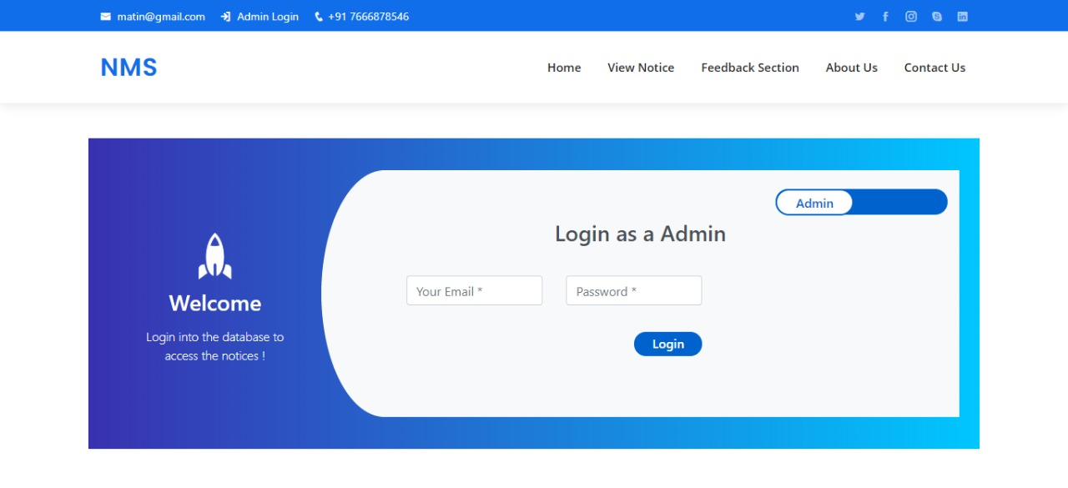

## Notice Board:

## 

1. Feedback Section:

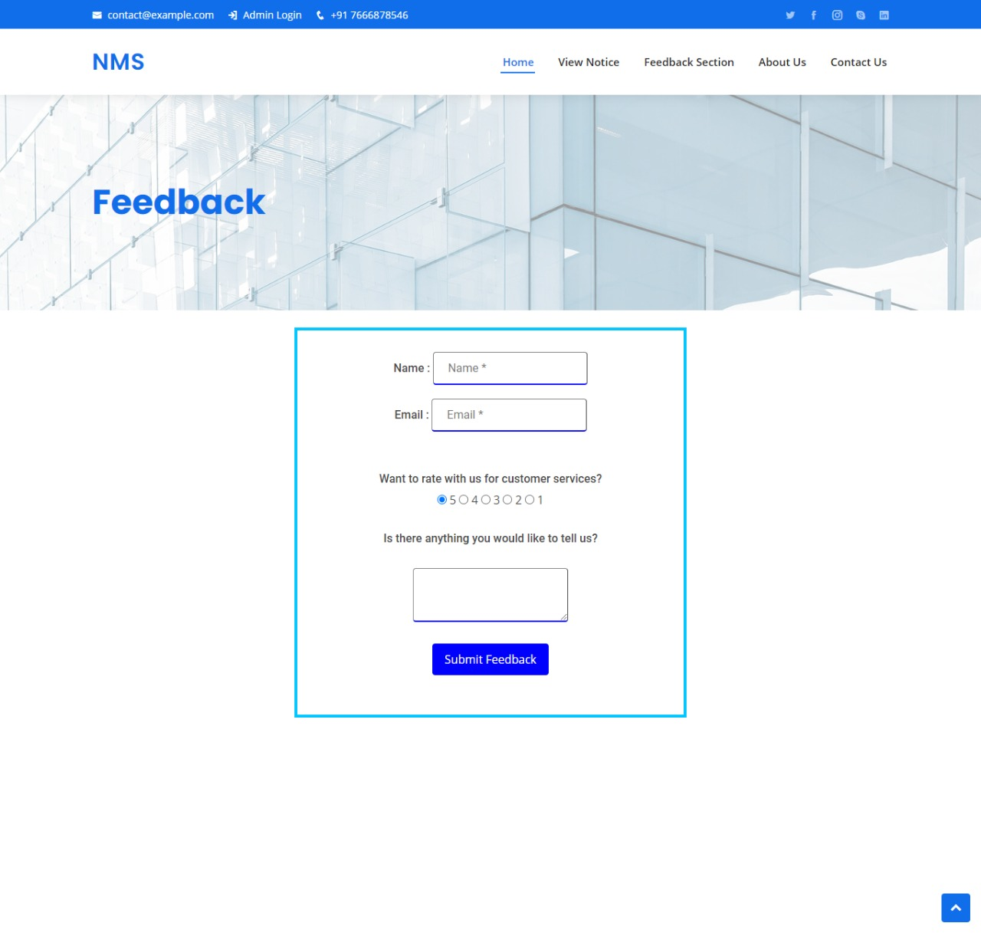

#### Operating Environment

###### Software Requirements

* Windows 7 Or Above Operating System
* Any Browser

###### Hardware Requirements

* Core I3 Processor
* 4 GB RAM

#### Design and Implementation Constraints

* Any One Can Visit the Website
* Should Use Less RAM and Processing Power.
* Any One Can Download the Marvel Movies from Here.
* Each Visitor/user Should have Individual email id and password

#### Assumptions and Dependencies

* Each User Must Have A Valid Email Id and Password.
* It Necessary for User to Login to The System to View and Download the Movies

## External Interface Requirements

#### User Interfaces

There Will Be Many User Interfaces According to The User Login.

User Login Will Have Interface For:

1. Download Movies
2. Give Feedback
3. View Info About Movies
4. View Info About Characters And used Synopsis

#### Hardware Interfaces

##### Laptop/Desktop PC

* + Core I3 Processor
  + 4 GB RAM
  + 1 TB HDD

#### Software Interfaces

##### Developer Computer Configuration

* OS- Windows 7/8/8.1- Very User Friendly and Common OS
* Any Browser

##### Require for Installation

* Sublime Text Editor
* Notepad ++

# System Features

There Should Be Two Types of System. Developer, Visitor Will Operate on Their Separate System and There Will Be A Link Between This Two Systems Which Will Use for Transfer O r D o w n l o a d Of Information.

## Nonfunctional Requirements

#### Performance Requirements

* Response Time - The System Will Give Responses Within 1 Second After Checking Any Information.
* Capacity - The System Must Support 1000 People at A Time.

#### Safety Requirements

If There Is Extensive Damage To A Wide Portion Of The website Storage Due To Catastrophic Failure, Such As A Disk Crash, The Recovery Method Restores A Past Copy Of The Website File That Was Backup To Archival Storage And Reconstructs A More Current State By Reapplying The Operations Of Transactions From The Backed Up Log, Up To The Time Of Failure.

#### Software Quality Attributes

* AVAILABILITY: The System Shall Be Available All the Time.
* CORRECTNESS: A Bug Free Website Which Fulfill the Correct Need/Requirements of The User/Visitor
* MAINTAINABILITY: The Ability to Maintain, Modify Information and Update Fix Problems of The System
* USABILITY: Website Can Be Used Again and Again Without Distortion.
* ACCURACY: The Reliability on The Information/Output.
* STABILITY: The System Outcome/Output Won’t Change Time to Time. Same Output Will Be Given Always for A Given Input.

 

# 

# Chapter 10: Special/Challenging Experiences Encountered During Training

Our Industrial Training Started on Zoom Cloud Meeting Platform. It Was Our Special Experiences to Work with Industrial Environment. This Was Not Too Easy for Us as We Were in College Environment at That Time. Listening All the Things and Concentrate on It Is Challenging Experience to Us as We Were at Home and We Are Attending Training on Online Platform. It Was Totally Different Type of Communication with Industry Than Communication Occurred in College. Development of Actual Website Is Challenging Experience for Us. Making the Screen Design User Friendly Was the Most Challenging Experience for Us. We Realized and Learned That the Designing Criteria and User-Friendly Criteria Is Different Aspects. So, Working for Customer’s Satisfaction Was Our Challenging Experience.

Working with JavaScript Was Special Experience for Us. Also, We Face Some Problems While Working Within Network Such as Connection Issues, Configuration Problems of Systems Etc. So, It Was Our Challenging Experience to Face That Problem and Avoid Data Loss from Such Occurred Problems.

# References/Bibliography:

###### [Brandtechnology.In](http://www.configsolutions.in/index.html)\About

* **W3schools\Reportsformat**
* [**Msbte.Org. In**](https://msbte.org.in/)**\Industrialtraining2020**